
Renewed Surface Water Management Program: DCD-Based Hybrid SWMS

The Hybrid Surface Water Management System (SWMS) sub-program is part of the renewed Surface Water Management Program (SWMP) in the Shepparton Irrigation Region (SIR).
The review of the SIR Drainage Strategy in 2015 identified the need for a new approach to surface water management due to continuing changes to the region, including a reduced irrigation footprint and less funding available for new drainage works.
These changes led to the development of the DCD-based Hybrid SWMS concept, which utilises a combination of Drainage Course Declarations (DCDs) over natural drainage lines and constructed SWMS where necessary, shown in Fig 1.
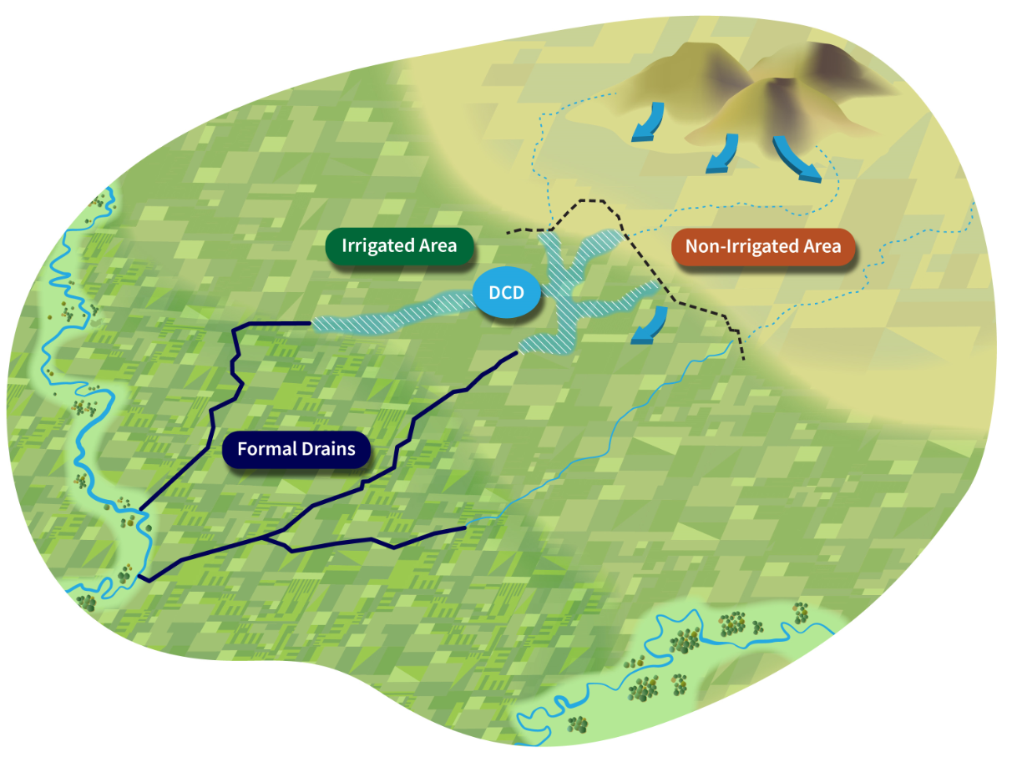
Fig 1 DCD Schematic
The objective of a DCD-based hybrid drainage scheme is to keep ‘reasonable’ water flows moving along natural drainage lines following major rainfall events, shown in Fig 1. By improving and removing obstructions to natural drainage courses, properties will be inundated or waterlogged less often and for a shorter duration than would otherwise be the case.
For further information please contact:
Goulburn Broken CMA
Telephone: 5820 1100
PO Box 175 Shepparton 3632
reception@gbcma.vic.gov.au

It is expected that DCD’s will provide opportunities to restore or partially restore natural wetland wetting and drying regimes and therefore mitigate
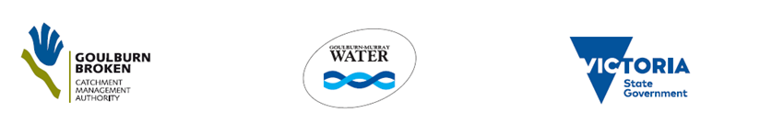

against risks associated with waterlogging and salinity in the catchment.
The implementation of the DCD will also provide increased outfall opportunities to waterways, with the potential to improve downstream environmental outcomes through greater flow and dilution benefits.
The service level provided by a DCD will vary depending on the local drainage attributes of the natural landscape and the capacity of the receiving drain or waterway, with the “reasonable flow” capacity being different for each drainage course.
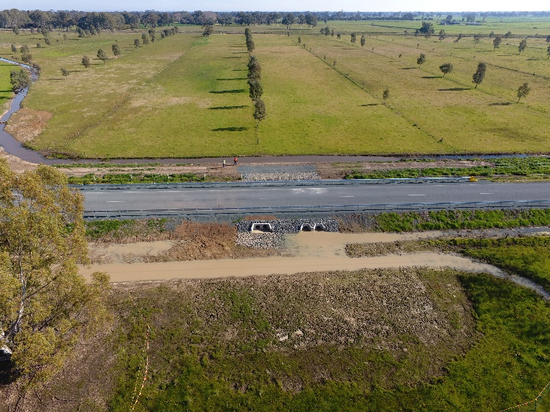
Fig 2 Upper Deakin DCD

Goulburn Broken CMA, in partnership with Goulburn-Murray Water have successfully implemented the DCD works programs for both the Upper Deakin and Cornella Creek DCD catchments in 2020; see Renewed SWMP Status of Projects Fact Sheet.

